Q1. Write a C/ Python program to implement a FCFS CPU scheduling algorithm. The
program should produce the ouptut sequence of the processes and waiting time for each of
the process.
Also implement the average waiting time for the process sequences and display the output.
For Example: Take the input sequence for the following processes:
i)
Process Burst Time
P1 24
P2 3
P3 3
ii)
Process Burst Time
P1 6
P2 8
P3 7
P4
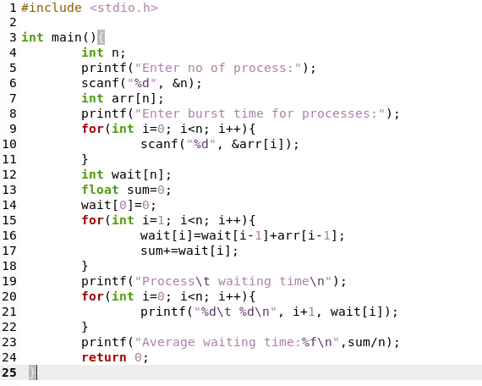
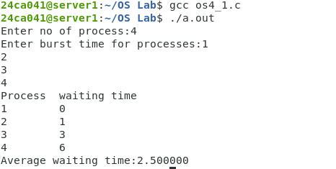

Q2. Using the exponential averaging method which is given below for estimation of the next
CPU bursts time of the process
Write a C/python program to estimate the next CPU bursts time for the process. Assume the
value of α is 1/2 and the initial value of τ0= 10.
The actual value of t1, t2, t3, t4, t5, t6 is 6 4 6 4 13 13
